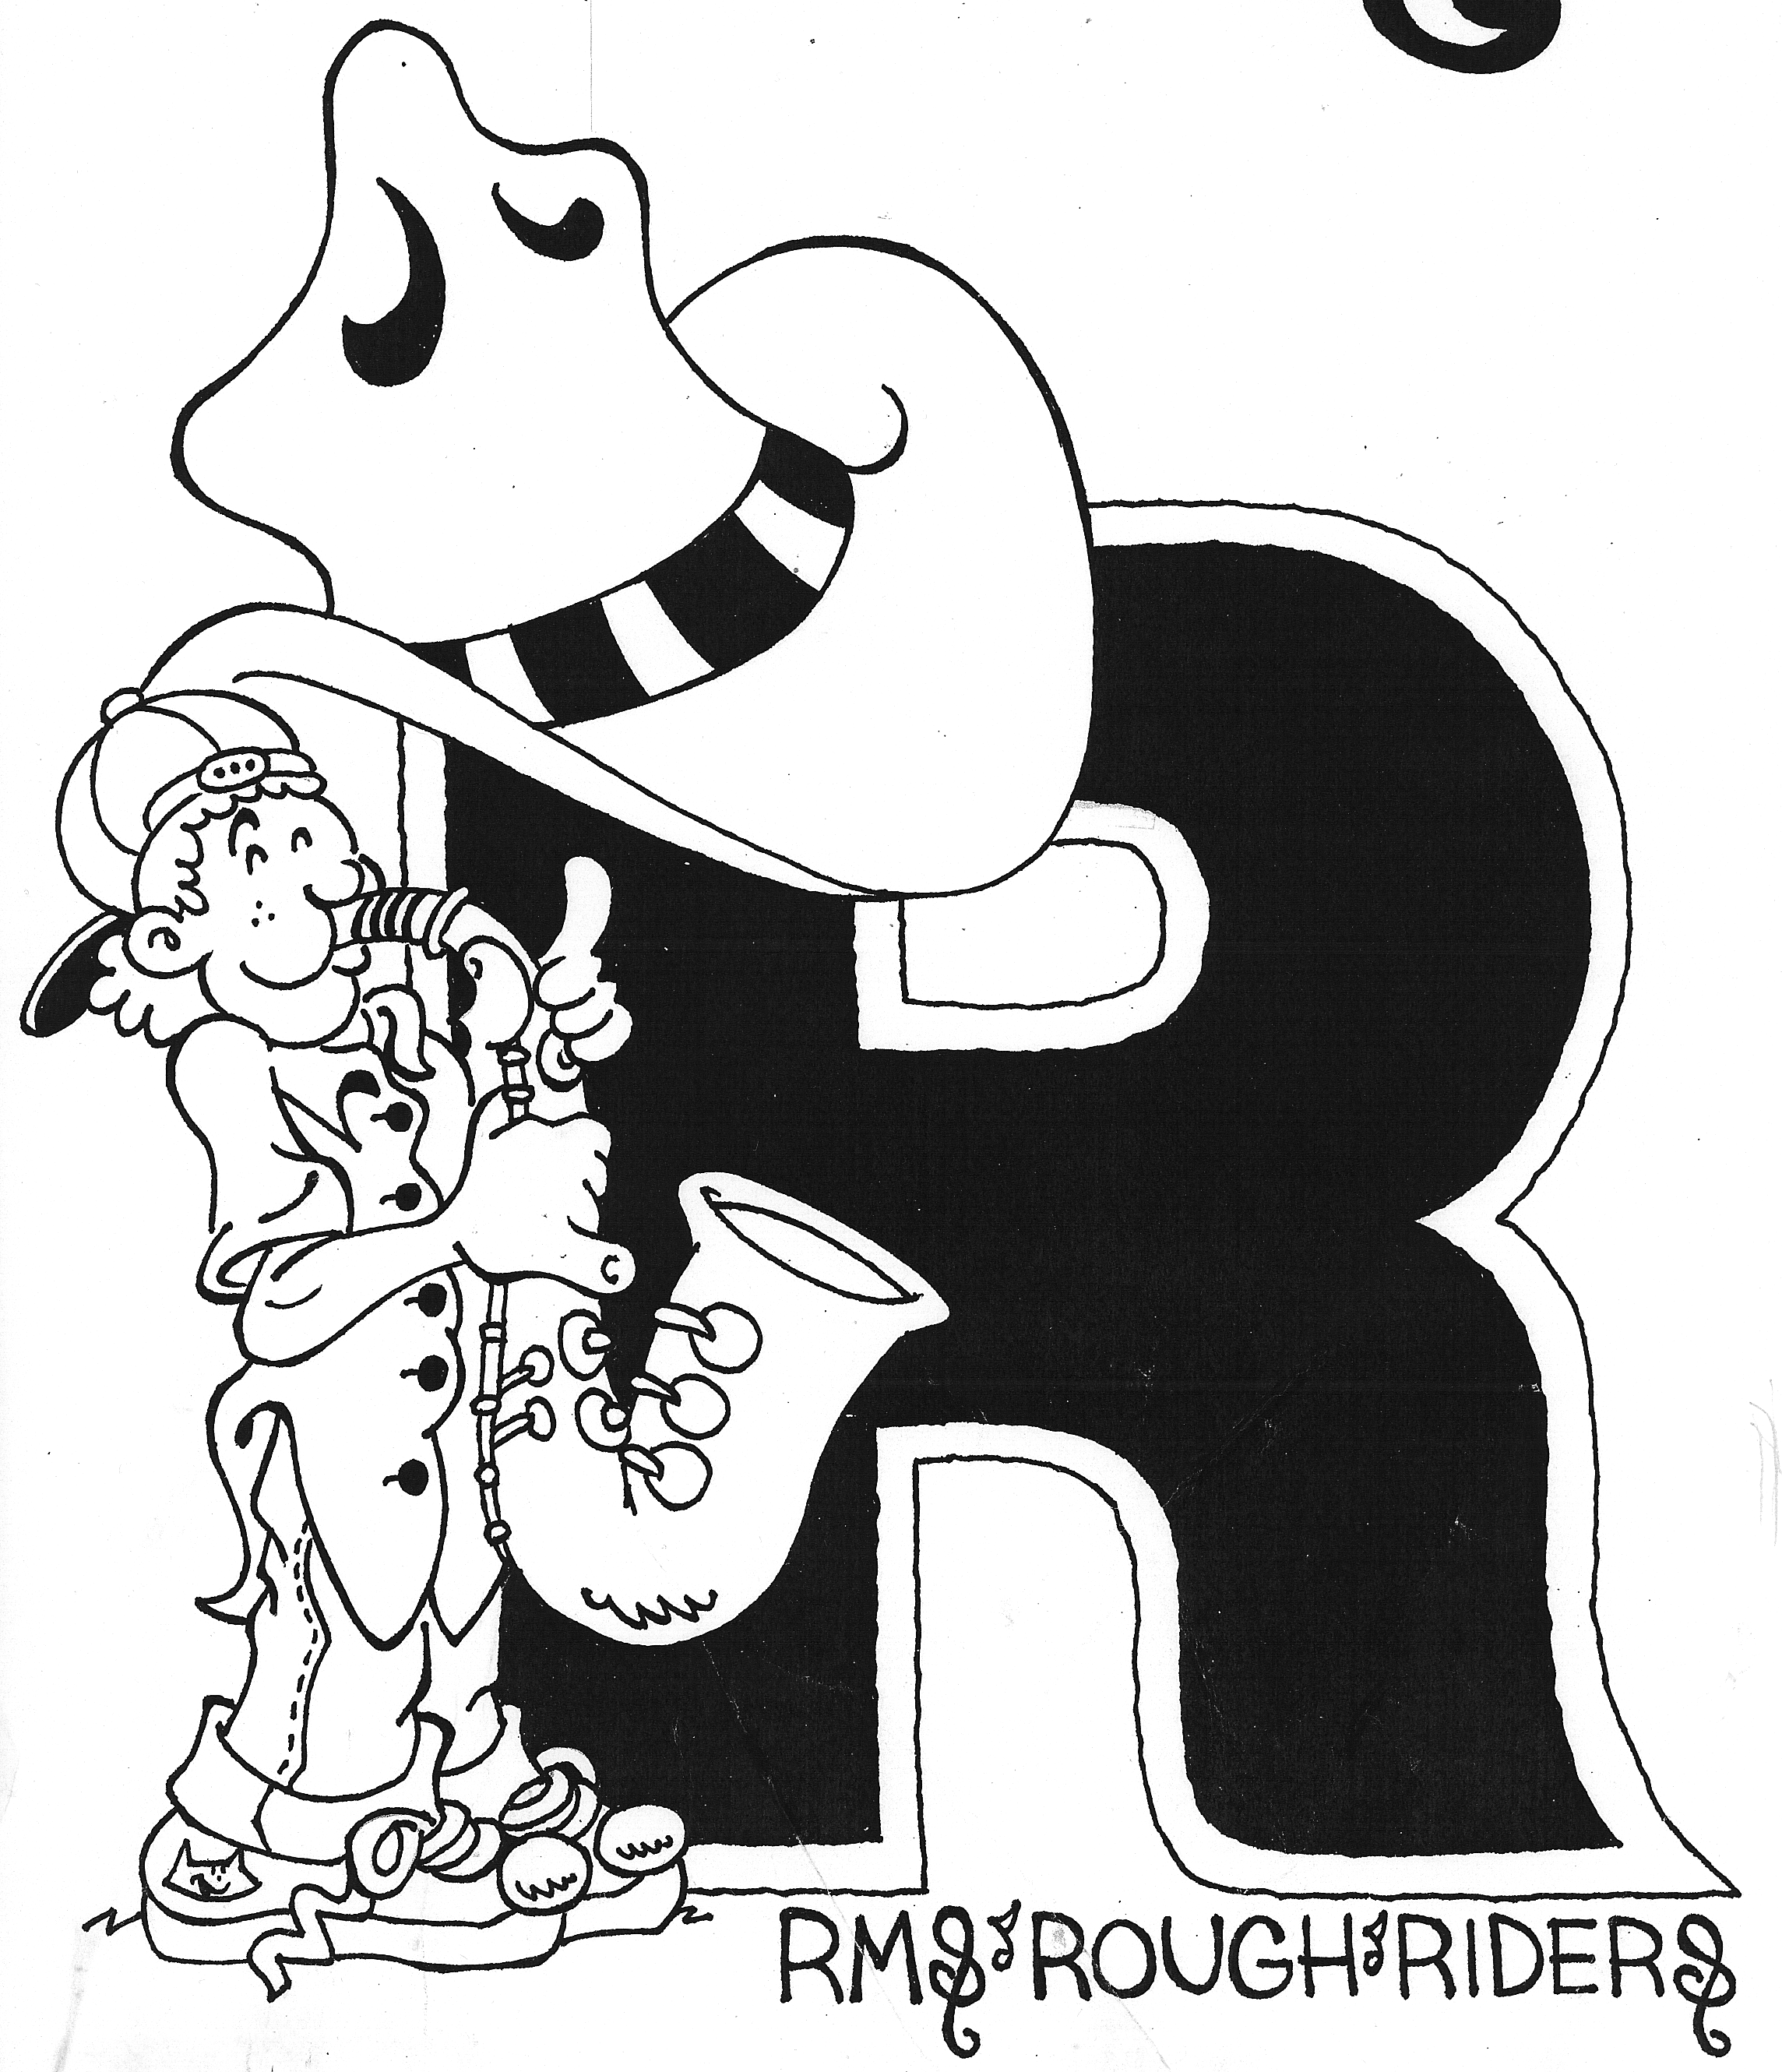

Roosevelt Middle School

Band Handbook

7th& 8th GRADE BANDS
&
Jazz Band

2017-2018

Mr. R. Bryson, Director

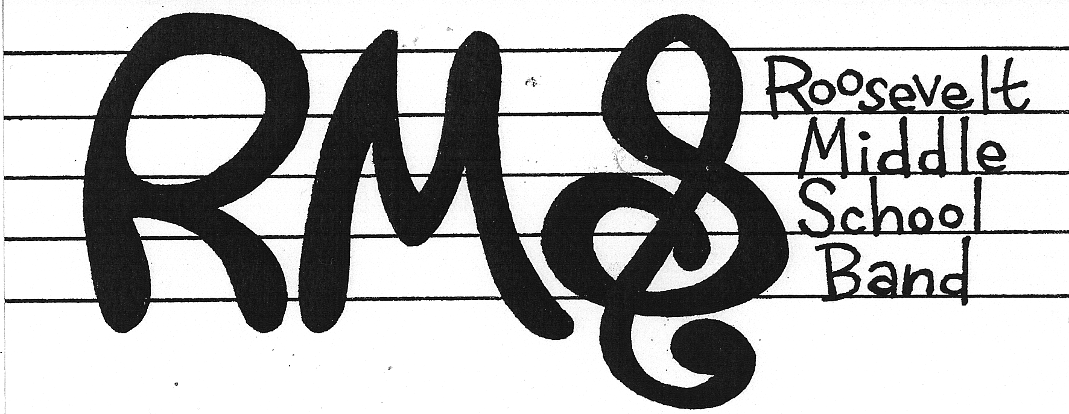
36 Gilbert Place
West Orange, NJ 07052

Mr. R. Bryson
rbryson@westorangeschools.org

Dear Students and Parents,
Welcome!
It is awesome to have you participate in the band program here at RMS. As you continue studying your instrument, you should experience tremendous growth as a student-musician in the middle school level. While music instruction requires commitment (home practice), the positive values and intrinsic rewards of music are life-long.

This handbook is intended as a guide and source of information for you and your parents to use throughout the school year. It will answer many basic questions about our program. If you have any further questions or concerns, please do not hesitate to contact me at the above email.

I look forward to your enthusiastic participation in making this a great year!

______________
Mr. R. Bryson
Band Director

GENERAL REQUIREMENTS AND PROCEDURES

Band Class
Students are expected to report to the band room with all necessary equipment for class. This includes: music book, instrument, band music, pencils, instrument accessories, and anything else needed for a normal rehearsal. Students who come to band class unprepared should expect to have points deducted from that portion of their marking period grade.

Classroom Rules

- Always raise your hand to speak!
- Only one person speaks at a time!
- Play only when asked!
- No playing or talking while teacher is at a teaching station
(Podium, board, or percussion pit)!
- Always be prepared (with instrument, music, book, & pencil)!

Mr. Bryson is serious about students following our classroom rules. In order for creativity to flow unhindered we must prepare the proper environment. Although there will be moments of down time, we are here to make music. Behavior that hinders the goal of making music will be addressed and dealt with appropriately. By signing the SIF in the back of this packet you are agreeing to cooperate with the rules. If a student fails to work within the confines of the classroom rules, parents will be notified and detention with Mr. Bryson will be assigned for the next available day. This will be done with a warning and two subsequent offenses. As a soccer fan, I will be using a “Soccer System” of the two yellow, one red card warning system. This will give students at least two chances to change the direction of the behavioral choices before a consequence is earned. If a student is given two yellows and a red card in one class period, they will be assigned a detention with Mr. Bryson and parents will be contacted by phone or email. If this detention is ignored, student will be given a general detention and the situation graduates to Mr. Lawrence’s desk. In addition, if a student is assigned three detentions within a marking period, a parent conference will be requested and future RMS trips and privileges could be jeopardized!

Home practice
Home practice assignments are given during band class. Students should keep track of their assignments by writing them in their agenda books. It is expected through the district initiative that students make a serious effort to practice at home at least 5 times a week for approximately 30 minutes each session.

Music
All students will be given their own music folder to keep their books, band and music for home practice.

Performances

Attendance at all concerts is mandatory! Concerts are the culminating activities of all rehearsals. Students will always receive information well in advance on any performance. Failure to attend any school performance will result in the lowering of the student’s marking period grade by one full letter grade. Note: Emergencies are excused with a written note from parents.

Our Winter Concert and Spring Concert dates are:

- Thursday, December 14th, 2017 7:00 PM
- Wednesday, June 13th, 2018 7:00 PM

These dates are subject to change due to the new PARCC schedule…

Performance Attire
Concert dress for performances and concerts will be as follows:

- Boys will wear black slacks, white dress shirt and dark shoes and socks.

- Girls will wear a long black skirt or slacks, with a white blouse and dark shoes. A long black dress is also acceptable.

End of the Year Performance Trip
Specific music groups (Select Chorus, Jazz Band ) will be invited to perform at a music festival trip. This trip is a full day event and privilege wherein students are adjudicated for their performance. The trip usually involves a theme park in addition to the performance (most likely Music in the Parks with Dorney Park). This trip is a privilege, and will be taken away from a student that refuses to abide by the Classroom Rules and expected code of conduct here at RMS.

Marking Period Grade

Five sections will be evaluated to determine daily grades. Each section will add up to a daily grade of 10 points possible. Concerts are worth 40 points each and concert rehearsals are 15 points each. These three categories will be averaged in power school to form the final grade.
A = 90-100; B = 80-89; C = 70-79; D = 60-69; F = 0-59

- Point Instrument and Accessories: Students are expected to attend all classes with their instrument and its’ accessories.

- Point Band Music: This applies to learning concert music.

- Point Book Music: Practicing assigned book music at home will help students develop and refine their skills on their instrument.

- Point Assigned Scales & Rhythms: Practicing assigned scales at home will help students understand the concept of key and its relationship as building blocks to music, as well as increase technical proficiency. Performing rhythms effectively in class will help transfer to all of their reading skills.

- Point Embouchure: The French word “embouchure” describes lip position. Each instrument has its own embouchure and practicing correctly and regularly will help develop one’s embouchure. Note: For percussionists, embouchure will mean, hand/stick position. Posture/Air: For wind players, utilizing excellent posture and breath support is key to playing well. Percussionists will be given points on posture only. Tone Production: Playing an instrument with its characteristic tone is rewarding and contributes immeasurably to the overall band sound.

5 Points Attitude/Effort – Participation: Band is a team-effort. When students participate with a positive attitude and make a genuine effort in band class, the entire team benefits. Students will lose points for fooling around, not following instructions, distracting other students from learning and so on. Participation grades are not based on individual talent, but attitude and effort. So if you at least try, you cannot fail!!!

EQUIPMENT AND STORAGE

Method Books: Sound Innovations Book 2
The board approved text for our band class is Sound Innovations Bk 2. Although we have copies for class use, if a student would like to purchase this book it would be helpful for individual home practice. The book can be purchased online or through any of our local vendors listed below. It is NOT a requirement to purchase the book.

Reed, Brass, and Percussion Instrument Players
In order for students to stay well prepared during class, reed, brass, and percussion instrument players are required to have special accessories that will enable the student to play and/or maintain his or her instrument properly. Failure to have these items may result in an instrument/accessories point(s) deduction.

Reed Instrument Players
- Need to have two working reeds at all times.
Brass Instrument Players
- Need to have valve/slide oil and cleaning rag.
Percussion Instrument Players
- Need to have snare sticks and percussion mallets (soft or hard).

Local Music Vendors
These local vendors carry a wide variety of reeds, lubricants, percussion equipment, books and other music accessories:

K & S Music 908-790-0400
Glenn Weber Drum Shop 973-736-3113
The Guitar Center 973-837-0855
Millburn Music 973-376-5112
The Music Shop 973-334-8484

Instrument Repairs

If a student’s instrument is in need of repair, the situation must be reported immediately. If it is a personal instrument, the student is responsible for either getting the instrument repaired him/herself or having the instrument repaired through the school, at the student’s cost. Repairs through the school are sent to K & S Music or The Music Shop. Parents can arrange to have the instrument picked up from RMS, fixed, and returned to RMS by Service Representatives, as they visit the school weekly. Note: A note from home must be sent to school when an instrument is being repaired.

K & S Music - 908-790-0400; Dave Elgart, ext. 48
The Music Shop -973-334-8484; contact Dave Bychek

Personally Owned Instruments
Instrument cases need to have the student’s name clearly labeled somewhere on the outside of the case. Many cases look alike, so labeling is imperative. Percussion students must label sticks/mallets.

Band Room Lockers
All students will be issued a locker in the band room to store instruments during the day. Instruments are to be taken home daily, so that home practice can take place. Lockers are treated as school property, therefore there is to be no writing on the lockers or name tags. In addition, students will not be allowed to enter another’s locker. Note: West Orange School District is not responsible for personal instruments or rented instruments left in school.

Co-curricular/Fundraising/Miscellaneous

Jazz Band *
Jazz Band is a co-curricular ensemble that meets weekly after school on Tuesdays, from 3:00-3:45. The Jazz Band performs at both winter and spring concerts, and at the District Wide Concert with all the jazz bands in the district.

*Privilege and Behavior

It is an honor and privilege to be in the Jazz Band. The music is challenging and children’s’ talents are refined and brought to the surface to shine. For this rehearsal Mr. Bryson will not be able to or interested in dealing with behavioral concerns. It is expected that those that come out to be in this program will excel in all areas of character and behavior.
For this purpose the “Soccer System” of two yellow and one red card will be utilized. Therefore if a student is asked to leave the rehearsal, they must wait outside for a ride or the bus. This would be their first yellow card. After a second yellow and one red card (two more times asked to leave rehearsal) they will no longer be a part of the jazz band, and will also be unable to attend the end of the year band trip and festival. No exceptions will be made. Parents will be notified of each offense. The administration will be notified after the second offense. If the student is asked to leave three rehearsals, they will no longer be allowed to rehearse or perform with the Jazz Band.

Any student interested in participating should attend the informational meeting on, Tuesday, September 26th , from
3:00 – 3:30 PM. Tryout materials will be passed out. Tryouts will be held on Tuesday, October 3rd, after school until finished.
*Attendance
For any ensemble to be successful, it is necessary for members to attend all rehearsals. Extended periods of absence will not only hurt individual progress, but will hinder the success of the entire group. All absences must be reported, and every situation/conflict can be worked around to keep the individual and the band happy! However, students that have excessive absences (except for sickness) may be removed from the Jazz Band at the Director’s discretion.

Fundraising
Fundraising is a great way to raise money for a good cause, and it helps the students take ownership of their organization. Each year, the music department hosts a successful Cheesecake fundraiser. Students that participate each year, raise money that is deposited in individual band accounts. The money helps to offset the cost to each individual that participates for our band trip to Music in the Parks, & Dorney Park. Please look out for information regarding this year’s fundraiser. It usually happens in March and product arrives in time for Easter/Passover.

Jr. Region Band & Jr. Region Jazz Auditions
Region Band and Region Jazz are two organizations that are not affiliated with the school, but students may participate in if they pass an off-site audition. These two musical groups are comprised of the North Jersey’s top middle school musicians. It is highly recommended that students audition for these top-flight challenging groups. Audition information will be provided to interested students.

Extra Help
Extra help is encouraged and available after school until 3:25 on Mondays, Wednesdays, and Thursdays. Please ask Mr. Bryson before or after class to set up extra help. Extra help must be sought out by the student.
Student Information Form

Name Grade
Student Email Class Period

Parent(s)/Guardian(s) First and Last Name and Work Phone:
home Cell Phone
home Cell Phone
Parent(s) email address(es)
Instrument Do you own your instrument?
Make (Name Brand) of your instrument
Instrument Serial Number (if possible)
What elementary school did you attend?
Do you study privately? If yes, with whom?

Statement of Agreement
The rules and policies in this handbook are to assist us in having the very best year possible. Please read this handbook with your parents/guardians and return this page, completely filled out and signed as soon as possible.
I have carefully read the Roosevelt Middle School Band Handbook and agree to abide by the policies set therein.

Parent/Guardian signature date

Student signature date

Please sign, fill out and bring to your next class. This is your first written assignment and grade!

